Neural Network in PyTorch
Let's build on the topics we've learned: Neuron → Perceptron → MLP → Activation Functions → Autograd → Backpropagation → Gradient Descent.
Now we'll combine these concepts to build and train a complete Neural Network using PyTorch.
1. Detailed Technical Explanation
What is a Neural Network?
A Neural Network is a machine learning model made up of interconnected neurons arranged in layers. It learns patterns from data by adjusting its weights and biases during training.
A typical neural network has three types of layers:
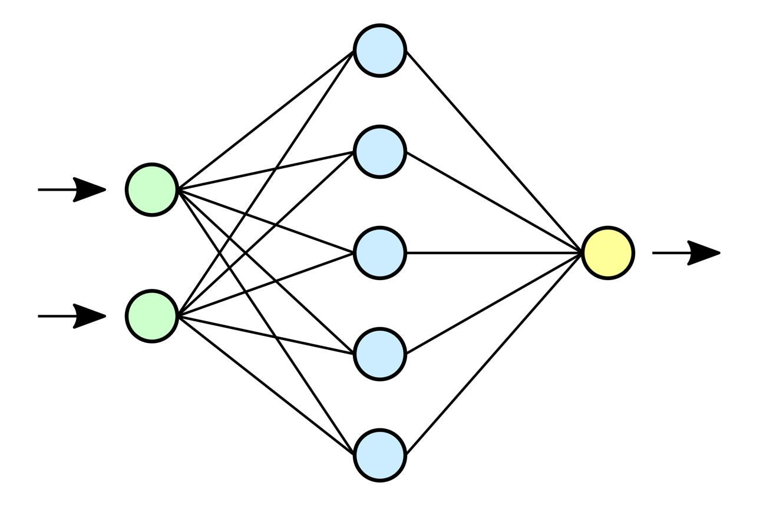
1. Input Layer
Receives input features, such as age, income, or house size.
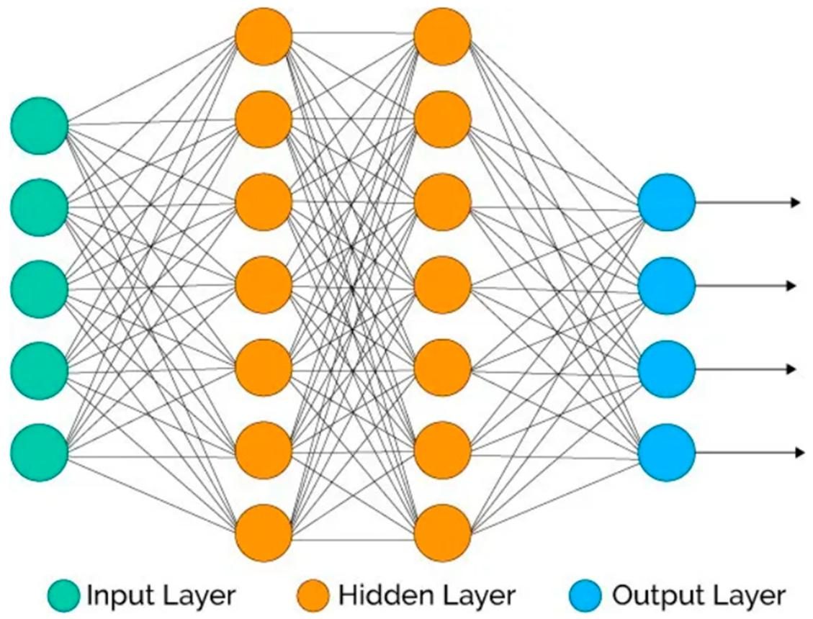
2. Hidden Layers
Learn patterns and relationships using weights, biases, and activation functions.
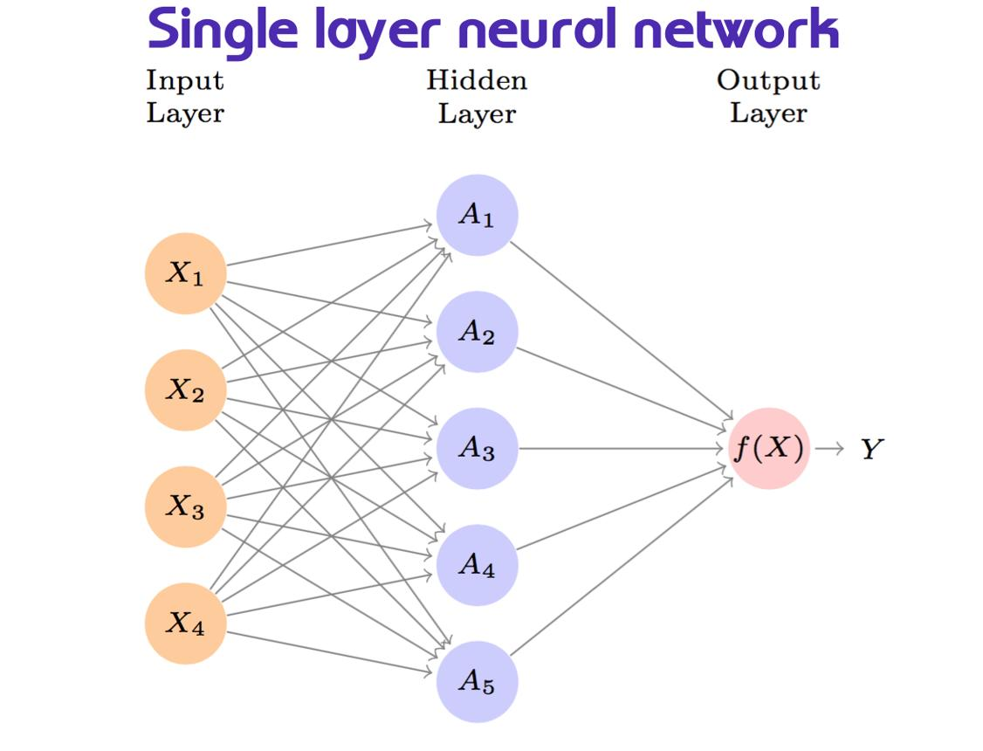
3. Output Layer
Produces the final prediction, such as a price, probability, or class score.
How does a neuron work?
Each neuron calculates a weighted sum and applies an activation function.
\[ z=Wx+b \]
\[ a=f(z) \]
Where:
- \(x\) = input
- \(W\) = weights
- \(b\) = bias
- \(f\) = activation function
- \(a\) = output of the neuron
For a multilayer network, the output of one layer becomes the input of the next layer.
Neural network training process
Input Data
↓
Forward Pass
↓
Prediction
↓
Loss Calculation
↓
Backpropagation (Autograd)
↓
Gradient Descent / Optimizer
↓
Update Weights
↓
Repeat
PyTorch provides tools for every stage of this process.
2. Real-Life Example: House Price Prediction
Imagine we want to predict house prices using three features.
Input feature | Example value
Area | 1,000 sq. ft.
Bedrooms | 2
Age of house | 5 years
Our neural network could have this architecture:
Input Layer
3 features: area, bedrooms, age
Hidden Layer 1
16 neurons + ReLU
Hidden Layer 2
8 neurons + ReLU
Output Layer
1 predicted house price
During training, the network compares its predicted prices with actual prices. It then adjusts its parameters to reduce the prediction error.
3. Code/Syntax Example — PyTorch
Step 1: Import libraries
import torchimport torch.nn as nnimport torch.optim as optim
- torch: tensors and mathematical operations.
- torch.nn: neural network layers and loss functions.
- torch.optim: optimization algorithms.
Step 2: Create training data
We'll use a small synthetic dataset where the target follows approximately \(y=2x_1+3x_2\).
X = torch.tensor([ [1.0, 2.0], [2.0, 1.0], [3.0, 2.0], [4.0, 3.0], [5.0, 1.0], [6.0, 2.0]])y = torch.tensor([ [8.0], [7.0], [12.0], [17.0], [13.0], [18.0]])
Here, X has two input features and y has one target value per sample.
Step 3: Build the neural network
class NeuralNetwork(nn.Module): def __init__(self): super().__init__() self.network = nn.Sequential( nn.Linear(2, 16), nn.ReLU(), nn.Linear(16, 8), nn.ReLU(), nn.Linear(8, 1) ) def forward(self, x): return self.network(x)model = NeuralNetwork()print(model)
Understand the architecture:
Code | Meaning
nn.Linear(2, 16) | 2 inputs → 16 neurons
nn.ReLU() | Adds non-linearity
nn.Linear(16, 8) | 16 neurons → 8 neurons
nn.Linear(8, 1) | Produces one prediction
nn.Module is the base class for PyTorch models. The forward() method defines how data flows through the network.
Step 4: Define loss and optimizer
criterion = nn.MSELoss()optimizer = optim.SGD( model.parameters(), lr=0.01)
- MSELoss() measures the average squared prediction error.
- SGD updates weights using gradients.
- lr=0.01 sets the learning rate.
Step 5: Train the network
epochs = 1000for epoch in range(epochs): # Forward pass prediction = model(X) # Calculate loss loss = criterion(prediction, y) # Clear previous gradients optimizer.zero_grad() # Backpropagation loss.backward() # Update weights optimizer.step() if (epoch + 1) % 100 == 0: print( f"Epoch [{epoch + 1}/{epochs}], " f"Loss: {loss.item():.4f}" )
The loss should generally decrease as the network learns, although the exact values depend on random initialization and training settings.
Step 6: Make a prediction
model.eval()new_data = torch.tensor([[7.0, 2.0]])with torch.no_grad(): prediction = model(new_data)print("Predicted value:", prediction.item())
The target relationship is \(y=2x_1+3x_2\), so the expected value for this example is \(2(7)+3(2)=20\). The trained network's prediction may be close to 20, but it is not guaranteed to equal it exactly.
How the code connects to what we learned
Concept | PyTorch implementation
Neurons and layers | nn.Linear()
Activation function | nn.ReLU()
Prediction | model(X)
Loss | criterion(prediction, y)
Clear gradients | optimizer.zero_grad()
Autograd and backpropagation | loss.backward()
Gradient Descent update | optimizer.step()
Number of training iterations | epochs
Important: This is a regression example, so the output layer has no sigmoid or softmax. For binary classification, we would typically use a one-logit output with nn.BCEWithLogitsLoss(). For multiclass classification, we would typically use nn.CrossEntropyLoss() with raw output logits.
4. Marathi Explanation — मराठी स्पष्टीकरण
Neural Network म्हणजे काय?
Neural Network हे अनेक neurons आणि layers वापरून data मधील patterns शिकणारे Machine Learning model आहे.
- Input Layer: Data स्वीकारतो.
- Hidden Layers: Weights, biases आणि activation functions वापरून patterns शिकतात.
- Output Layer: अंतिम prediction देतो.
Training कसे होते?
- Input model मध्ये दिला जातो.
- Forward pass मधून prediction मिळते.
- Actual आणि predicted values मधील loss मोजला जातो.
- loss.backward() gradients calculate करतो.
- optimizer.step() weights आणि biases update करतो.
- ही प्रक्रिया अनेक epochs पर्यंत repeat होते.
🧠 Handwritten Notes / Memory Trick
Neural Network
↓
Input Layer
↓
Hidden Layers
↓
Output Layer
↓
Loss Calculation
↓
Backpropagation
↓
Gradient Descent
↓
Updated Weights
एका ओळीत लक्षात ठेवा:
Neural Network म्हणजे layers मधून data process करून, loss आणि gradients वापरून weights update करणारे model.
Next topic: Neural Network Training Loop in PyTorch — Dataset, DataLoader, mini-batches, epochs आणि validation यांचा वापर करून अधिक realistic training pipeline तयार करणे.

